Senator Carolyn Stewart-Olsen

**carolyn.stewartolsen@sen.parl.gc.ca**

17 October 2014

Dear Senator,

We would like to thank you, and through you your fellow Senators, for allowing us the opportunity to appear as Witnesses before your Committee on October 7th, 2014 to speak with you about aquaculture in Georgian Bay and Lake Huron and present our concerns with the open netcage aquaculture industry expanding in the Great Lakes.

We offer this letter as summary and further assistance to the Senate Committee on the topic of regulation and future prospects for the aquaculture industry specific to the Great Lakes. This is our area of mandate and focus.

Given the decline in native fish stocks, the increasing consumer demand for fish to eat and the desire to supply this demand locally and create local jobs in the process, the Georgian Bay Association (GBA) agrees there could be a very bright future for aquaculture in Canada. Responsible growth for this industry in Canada requires an environmentally sustainable futuristic plan that does not trade off the health of its abundant natural freshwater resources for the sake of jobs and economic growth. Moreover the growth of the freshwater finfish industry requires a strong social licence with support from both the consumer and the major retail chains that sell fish. Trends in the retail market indicate that the public is aware and concerned about buying healthy choices produced in an environmentally responsible and organic fashion. Both the technological expertise and scientific research shown by GBA’s aquaculture committee confirms that the technology for organically grown, closed contained systems of aquaculture is here and is more and more economically viable to conduct on a commercial scale than ever before.

The GBA is a stewardship organization with a mandate to protect Georgian Bay/ Lake Huron (where open netcage rainbow trout farms are located). The effects of the open netcage aquaculture operations here, also impact on the International, National, and Provincial plans all in place to protect the Great Lakes in a whole ecosystem approach. We firmly believe licence should not be given to the open netcage aquaculture industry operating within the Great Lakes. We recommend that an addendum be given to the National Aquaculture Strategic Aquaculture Plan Initiative: Freshwater Plan (2011-2015) that specifically protects the very fragile state of the Great Lakes and what this implies for aquaculture initiatives. The Federal and Provincial governments should not approve any expansion of this industry using open net cages. Furthermore, the existing operators should be given a timeline and means of support for converting their existing open net cages to closed containment systems.

From a political perspective, the Great Lakes are a bi-national waterway that is co managed by the US and Canada. There are multiple bi-national agreements (i.e. the Great Lakes Water Quality Agreement, the Great Lakes Binational Toxics Strategy) and multiple bi-national agencies (i.e. the International Joint Commission, the Great Lakes Fisheries Commission). Given this we feel that the Canadian government needs to be a major participant in any discussions and decisions on the future of aquaculture in the Great Lakes. The problems with Phosphorous loading into the Great Lakes and the increase of algal blooms that result are well documented.

During our appearance before you we were asked if there have ever been algal blooms near cage aquaculture operations. Our answer was, no. We have been corrected by one of our science advisors who watched our session. He reminded us that there had indeed been an algal bloom at the Lake Wolsey operation in 2006. Lake Wolsey is attached to the North Channel adjacent to Manitoulin Island. The algal bloom was documented by a PhD candidate, Kelly Amber Hille, who happened to be conducting water quality research at that site when the bloom occurred. We are attaching two pictures that she took of that bloom around and in the cages and an excerpt from the conclusion in her 2008 report that the fish farm “plays a part” in triggering this bloom.

Sincerely,



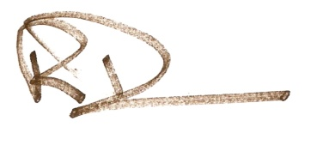

Claudette Chabot Bob Duncanson

Chair - Aquaculture Committee Executive Director

Georgian Bay Association Georgian Bay Association

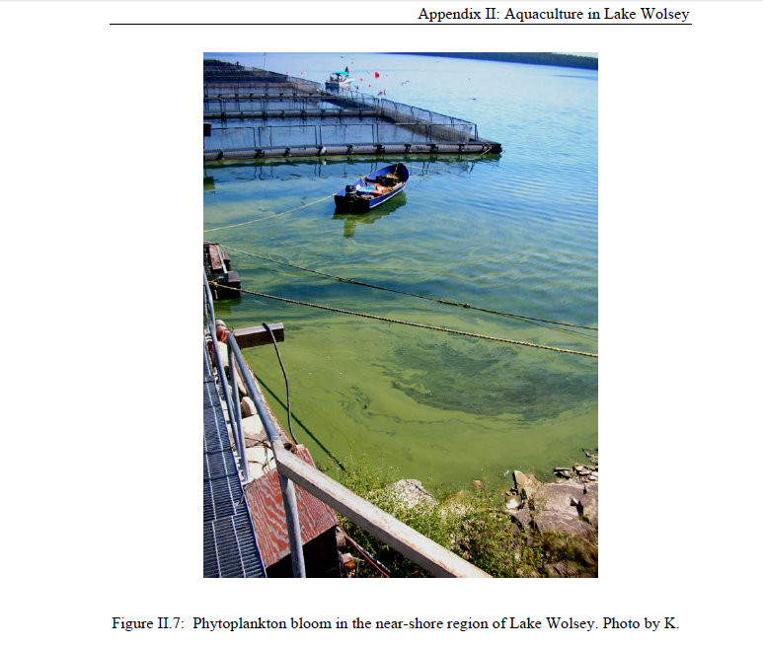

The pictures above and below are from a research report published by Kelly Amber Hille in 2008 on the effects of cage aquaculture on epilithic biofilms.

The portion of her report that focuses on Lake Wolsey concludes in part, “even though the aquaculture operation may not be the main impacting agent on the system, it still plays a part. Every new invasion, every added nutrient and every physical change to the system adds stress to this already highly disturbed system.”

