Lake Wolsey Aquaculture Brief

Background

The Georgian Bay Association (GBA) has monitored the activities of the Ontario aquaculture industry for the past 20 years and engaged in an ongoing dialogue with the industry and government. Over the years we have voiced our concerns that this industry, through its use of open net technology, has an unsustainable environmental impact on the public waters where these cage farms operate. GBA’s science advisory committee has calculated that the cage farms collectively release 55 tonnes of phoshorous into public waters annually (at current feed quota levels).

Lake Wolsey on Manitoulin Island has been the site of a cage aquaculture operation (currently Blue Goose) since the 1980s. Lake Wolsey is an embayment connected to the North Channel.

Issue

Over the years there have been regular outbreaks of Blue Green Algae on Lake Wolsey (1999, 2006, 2010, 2011, 2013, 2015 and 2016). Notably these have all occurred subsequent to the start of commercial fish farming in this Lake. GBA is aware that scientists from the Ministry of Environment and Climate Change have done field research to determine the reasons for water degradation in Lake Wolsey.
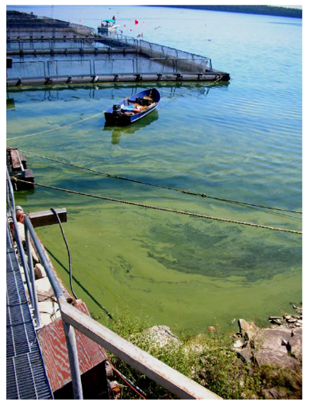
The picture above is from a research report conducted by Kelly Amber Hille in 2008 on the effects of an experimental cage aquaculture operation on epilithic biofilms.

GBA has been frustrated by the lack of information coming from the Province on research being done on Lake Wolsey. As a result, we initiated freedom of information requests to the Ministry of Natural Resources and Forestry and the Ministry of Environment and Climate Change for any written documents regarding Lake Wolsey generated over the past two years. While we are still waiting for MOECC to respond, what we have learned from the information provided by MNR&F is very concerning.

Science

In a December 2015 presentation entitled, “Overview of Lake Wolsey Water Quality and Source Loading Assessment” the government made a statement about Lake Wolsey that, “Harmful Algal Blooms (HABs) are a regular occurrence since 2006”. They also stated that, “Lake Wolsey is identified as a Policy 2 site where the quality of water does not meet the Provincial Water Quality Objectives” and that it, “shall not be degraded further and all practical measures shall be taken to upgrade water quality to the Objectives.”

In February of 2016 the MOECC issued two reports, The State of Lake Wolsey
Water Quality Dynamics and The State of Lake Wolsey Part II: Source Loading Assessment.
These were authored by Ngan Diep and Duncan Boyd.

The first report uses monitoring data for the Lake Wolsey operation, along with results from an Environment Canada lake-wide phosphorus survey, to augment data collected by the MOECC water quality monitoring program. It documents historical and recent limnological conditions, with particular emphasis on the extent of the hypolimnetic Disolved Oxygen (DO) depletion observed in this embayment, and tracks changes in the environmental condition of Lake Wolsey over the period 1986 to 2014. DO is an essential component of aquatic ecosystems and significant depletion of DO can compromise the ability of a waterbody to support aerobic aquatic communities. Hypolimnetic dissolved oxygen (DO) depletion leading to anoxia, or the near absence of DO, can lead to degradation or loss of benthic environment which can have an impact on sediment-dwelling biota.

The main finding is that, around the time that harmful algal blooms (HABs) were first reported, there was a downward shift in the DO concentrations during the summer or stratified period of both the bottom layer (hypolimnion) and the layer straddling the thermocline (metalimnion).
These HABs have occurred on a regular basis since 2006. Wide-spread hypolimnetic anoxia occurring since the mid-2000s, around the time harmful algal blooms were first observed in this system, is now a chronic condition observed as recently as 2015. Volume weighted hypolimnetic DO depletion rates from 2002 until 2015 in Figure 43 and Table 11 of this report demonstrate this shift, which the authors term as “a tipping point” for the Lake Wolsey system.

The second report examines the likely causes for the widespread anoxia in the bottom and middle layers. Phosphorus in both dissolved and particulate forms mainly stemming from the continued high fish production stimulates primary production, which in turn creates an oxygen demand. Added to this is the recycling of phosphorus from deposits of fish waste accumulated over many years on the bottom, referred to as internal loading. Anoxic conditions are necessary for internal loading to take place. The authors carefully examine other possible sources for phosphorus and find them to be negligible in comparison to agricultural and aquaculture inputs, Unfortunately, the rate of phosphorus recycling is not easy to measure so was not part of the observational program. However, using internal loading estimates published in the literature for freshwater fish farms the authors point out that the estimate of internal loading used by Milne et al. (2015) is two orders of magnitude smaller than literature values.

Another possible contribution to the reduction of oxygen concentration is the oxidation of organic matter. The largest controllable source of organic matter is fecal waste followed by food not consumed by the fish.

The authors point out that the Lake Wolsey system is the only Type 2 system in the North Channel that has a hypolimnion not connected to the North Channel, because it is deeper than the channel that connects the embayment. Therefore, there is no natural replenishment of the oxygen in the bottom layer via flushing with oxygenated waters from the North Channel, unlike other fish farms in the area.

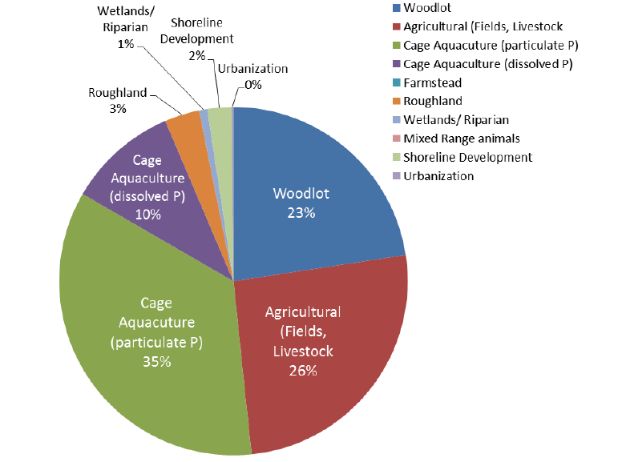

Figure 19 from The State of Lake Wolsey Part II: Source Loading Assessment, page 51: Allocation of phosphorus load to land-use categories and sources in Lake Wolsey and its watershed

Industry Response

The response from the Aquaculture Industry to these reports was predictably defensive. They claim that the phosphorous loading from land based agriculture is greater than from the cage farm. They point out that the surrounding geology is broken limestone karst which could result in land based phosphorous seeping directly into the Lake. They also point to statements made by one scientist to the effect that the fish manure is composed mainly of fish bones from ground up fishmeal and that these bones are made from the mineral apatite which is not broken down in the environment. Therefore, most of the Cage Aquaculture particulate should not be included in any phosphorous (P) loading calculations.

GBA’s scientists refute this assertion and point to other scientific studies that have been made on Lake Wolsey (Hamblin and Gale 2002) that assumed that eventually all fish farm P was returned to Lake Wolsey.

Although not mentioned in the reports it is instructive to review the history of the farming operations in the La Cloche Channel for similarities to the Lake Wolsey situation. The hypolimnion at La Cloche Channel is disconnected to the rest of the channel as is Lake Wolsey. The La Cloche operation, which could be classified as Type 2, began in 1985. The predevelopment trophic status was oligotrophic (P 4-5 μg/l, hypolimnetic DO 5mg/l). A second farm started in 1989 at a nearby site. Public complaints regarding algal growth in the channel prompted water quality testing by the MOE in 1997. These tests revealed low oxygen levels with 5-9 mg/L dissolved oxygen in surface waters to 12 m depths, but anoxic conditions in depths greater than 13 m (encompassing the entire hypolimnetic volume over a 250-ha area). Phosphorus concentrations were in the eutrophic range. The Ministry did not renew the land-use permit and by May,1998, all fish were removed from the site.

Anoxic conditions were still observed in the hypolimnion when we visited the abandoned farm site in the summer of 2000. This does not bode well for the elimination of HABs and the restoration of water quality to meet Provincial Water Quality Objectives in Lake Wolsey should the fish farm's land tenure not be renewed. If HABs continue to occur after termination of farming operations due to internal loading of phosphorus, remediation such as dredging and sand capping of the manure deposits may be required. As the land tenure area plus10 m on each side is 2.1 ha such remediation would be a costly operation.

But we feel that this arguing between scientists takes away from the main point in the MOECC reports – Water Quality in Lake Wolsey and specifically the Dissolved Oxygen Measurements is failing to meet the Provincial Water Quality Objectives. The Province should be taking all necessary steps to resolve this problem starting with addressing the nutrient inputs from the cage aquaculture operation that is clearly the largest contributor to the problem.

Next Steps

On the aquaculture side we have seen a document from MOECC to MNRF suggesting a reduction in feed quota. The response from MNRF to MOECC was that, if the MOECC want to limit the aquaculture operation, they should issue a Ministry Order.

While a reduction in feed quota can be done under the terms of the MNRF licence it can be expected that the operator may threaten legal action.
With a Ministry Order the operator may launch a challenge through the Ontario’s Environmental Review Tribunal. This may make the most sense as it would require an objective third party to review the science and make a binding decision to break the impasse between the two Ontario Ministries.

